**Interactive 3D Intelligent Map System**

by

Haiyun Zhou, Frank

(l630003071)

A Final Year Project Thesis (COMP1001; 3 Credits)

submitted in partial fulfillment of the requirements

for the degree of

Bachelor of Science (Honours)

in

Computer Science and Technology

at

BNU-HKBU

UNITED INTERNATIONAL COLLEGE

November, 2019

## DECLARATION

I hereby declare that all the work done in this Project is of my independent effort. I also certify that I have never submitted the idea and product of this Project for academic or employment credits.

**Haiyun Zhou, Frank (l630003071)**

##### Date: November 21st, 2019

**BNU-HKBU**

**United International College**

Computer Science and Technology Program

We hereby recommend that the Project submitted by Haiyun Zhou, Frank entitled "Interactive 3D Intelligent Map System" be accepted in partial fulfillment of the requirements for the degree of Bachelor (Honours) of Science in Computer Science and Technology Program.

##### Haiyun Zhou, Frank (l630003071) _________________________

##### Date: November 21st, 2019 Date: ___________________

## ACKNOWLEDGEMENT

I would like to express my great gratitude towards my supervisor, Dr. Hui Zhang, Amy who had given me invaluable advice to this project. I am also very grateful to Dr. Hui Zhang for providing us with different kinds of advance devices. Without these devices, we cannot even start this project. Besides, I would give a great thanks to some expert from the internet who give me tips and suggestions for using software like 3ds max and 3d reconstruction tools.

## ABSTRACT

This paper is mainly about how to implement a virtual campus system using a high-precision 3D model. There are many previous programs which use panoramic technology to view a sight in a spherical picture, like Google street view, but we can not see the whole structure of buildings and move the cordinate. Some other 3D virtual campus programs build the models only by CAD tools. For the purpose of build a 3D recontrution model of campus and embed interaction functions into the virtual campus program, these works require the piror knowledge of 3D reconstruction algorithm for monocular vision and computer graphics. In this paper, we create a novel idea of building a vitrual campus system. The campus photos obtained through multi-angle shooting must first extract the image features through the convolutional layer of deep learning for matching. The extracted features will generate a sparse 3D point cloud through Structure From Motion (SFM). Multi View System (MVS) will then generate a clear 3D dense point cloud by matching every pixel in the photo. Finally, the point cloud model can be transformed into a mesh model by expanding the point cloud into triangles. Interaction is related to transformational matrix, Coordinate-space Transformations and decision of behavior tree. These parts collaborate with each other, and change the Boolean relationship between them through the change of the coordinate space between the rigid body and the collision box, thereby achieving the interactive CG animation effect. Using the novel idea of building a vitrual campus system, this system can be also regard as a 3D sandbox game wich the performance can be similar to the virtual reality. Experimental results on real data sequences are presented, which the better effect implmented by the proposed idea.

## CONTENTS

Contents

DECLARATION 2

ACKNOWLEDGEMENT 4

ABSTRACT 5

CONTENTS 6

1. INTRODUCTION 7

2 RELATED WORKS 7

2.1.3 Related theory 8

2.33D Reconstruction 10

2.3.1 Principle 10

2.5Game Development (Unity with C#) 10

2.5.1 Character controller 10

2.5.2 Map system 13

2.5.3 Weather system 18

2.5.4 Interaction 20

2.5.5 UI and animation 22

2.5.6 Optimization 23

3 VIRTUAL CAMPUS SYSTEM 25

4 EXPERIMENTAL RESULTS 25

2.2 System pipeline 25

2.3.2 Workflow 26

2.1.2 Related devices 27

2.4Model Refining 29

2.1.1 Related software (based on Windows 10, x64) 29

2.4.1 Impact of model’s format 33

2.4.2 External influence of model quality 33

2.4.3 3ds max’s operations 34

5 DISCUSSIONS AND CONCLUSIONS 36

2.3.3 Improvement 37

REFERENCES 38

APPENDICES 40

# 1. INTRODUCTION

Many university in the world has its own vitrual campus system for visitors and freshman to use to fimilar with campus quickly. The final goal of UIC virtual campus system is also the same, but it has more interesting functions in it. When outside visitors come to visit the campus, they can familiarize themselves with the campus firstly in a 3D virtual scenario which projected to the wall. Wearing 3D glasses, they will feel like they are in a real campus scene. It is more like a 3D game, since it has several interactive triggers for users to find by themselves. There are also some attractive animation effects which makes this program has more intense visual impact. It's not only a 3D model that you can just look at it, figure it out which is the shortest path from your location to the location you think of, but also a vivid video game which introduces UIC in a special way. Our motivation comes from other fantastic 3A masterpiece games. Users can control the characters (or themselves) in a huge scene, move around and simulate real-life activites by pressing the specific key on the keyboard, look around by moving mouse. This program is also considered about making functions like those games, give the sense of reality to people who use our program. In addition, several professional CG software and different kinds of camera equipment were used to get the required materials. Finally, Unity editor provide a enviroment to wirite script and combine them into the final project.

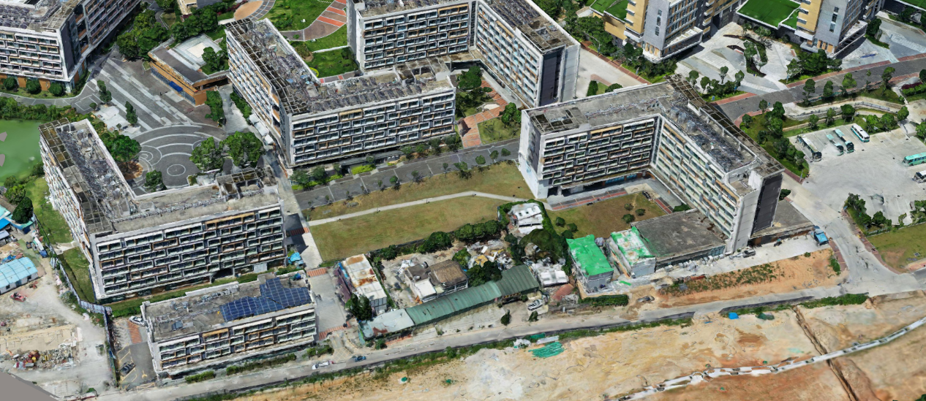

**Figure 1: campus using DJI Mavic 2 Pro and Smart3DCapture**

3D reconstruction has been developed for many years, and there have been many research methods and theories since the last century. In the early days, people used the Biplanar Reconstruction Method [1] to apply medicine, which mainly used X-ray, and most of the scans were small models. In this paper, method which bases on OpenCV will be provided. It is composed of a series of mainstream modeling frameworks, and references many classic calibration algorithms, such as linear algorithm (DLT), non-linear algorithm, two-step algorithm (Tasi) and Zhang Youzheng's plane calibration method to achieve photo preprocessing with position correction. Also, real-time reconstruction is a trend to build big-area model with high efficiency. Technology like SLAM using robot with sensor and camera can reconstruct a strange area automatically [2]. However, it is not the current mainstream modeling technology. If you are pursuing accuracy, it is best to use the method of generating point clouds based on camera calibration and deep learning matching features mentioned in this article. In [3], [4], traditional game designer used models which create by CAD tools, which is far from the real degree that the method proposed in this paper can achieve.

Virtual Campus is not just a series of changes to the model in the coordinate space caused by the transformation matrix, or a single campus model [5]. A very important concept is to reduce the motion of the rigid body in the three-dimensional space into the scene model in the related scale, and add behavior tree to add different functions at each node which realizes a true virtual campus tour.

Since all map systems need the navigation function, Dijkstra’s algorithm and ArcGIS implement many GPS system on mobile phones or embedded system in car [6]. For saving computing power and hardware requirements, we A-star algorithm is perfectly suitable for designing a game system.[7]

# 2 RELATED WORKS

Aerial triangulation is the most important theory for tilt photography modeling. Aerial triangulation is a method of measuring the elevation and plane position of an encrypted point by performing control point encryption indoors based on a small number of field control points in stereo photometry. Its main purpose is to provide directional control points for area maps that lack field control points. There are two types of aerial triangulation: simulated aerial triangulation, i.e., optomechanical aerial triangulation; and analytical aerial triangulation, commonly known as electrical encryption. Simulated aerial triangulation is an aerial triangulation performed on a versatile stereo measuring instrument such as a multiplier. It is a three-dimensional model of the route that is like or corresponding to the time of recovery on the instrument. The encryption point is selected according to the mapping and the elevation and plane position are determined. Good aerial triangulation results will make the reconstructed model more precise, reducing the appearance of the model layering and the uneven surface of the model.

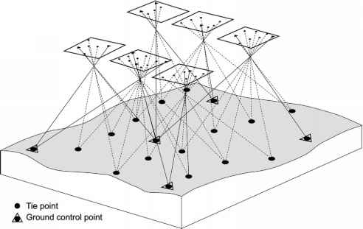

**Figure 7: Aerial triangulation**

### 2.1.3 Related theory

* **Shortest paths algorithm** is the core for navigation function. Before the project starts, there are different shortest paths algorithm be compared with each other, such as Dijkstra's algorithm, BFS, DFS, etc. Finally, A-star algorithm can be the most suitable one for this project. This algorithm not only saves the required memory, but also provides different distance heuristic formulas, let us choose the most suitable one according to different situations. Most importantly, it is the fastest algorithm, and is ideal for use in game development.

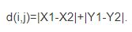

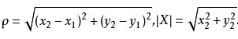

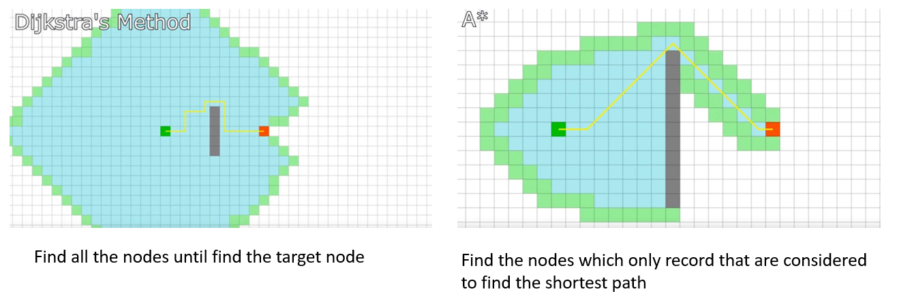

**Figure 9: Comparison between Dijkstra's algorithm and A-star algorithm**

* **Optimization** is the final step and the most crucial step in game development. If you want to make the game program have smooth performance, you need to add some optimization algorithms and optimization mechanism to the game. Quad trees and octrees are a common way to load game resources. This game is not required to load all the resources (models, pictures, sound sources, etc.) into the scene at the beginning, which will put a lot of burden on the hardware of the computer. This will result in the decreasing in the number of frames, a long response time, and a long wait for switching to another scenario. If resources can be loaded according to the above data structure, these problems will be greatly improved. Unity's own engine also has related optimizations, such as: reducing Draw call via Mipmap, optimizing AssetBundle packaging mechanism to save memory, and multi-threaded 3D rendering channel to make the picture smoother. For model optimization, the best way is importing model into 3ds max to optimize the number of vertices and triangles. Producing three different precision models when rebuilding is the second way of model optimization. It is called LOD technology (Level of Detail). In Unity, the scene will be based on the degree of scaling selects models that exhibit different precisions (the larger the angle of view, the finer the model is displayed), enabling dynamic loading of data.

# 3 VIRTUAL CAMPUS SYSTEM

3D reconstruction refers to the establishment of a mathematical model suitable for computer representation and processing of 3D objects. It is the basis for processing, manipulating, and analyzing its properties in a computer environment. It is also a key technology for building virtual reality in computers to express the objective world. In computer vision, 3D reconstruction refers to the process of reconstructing 3D information from single-view or multi-view images. Since single video information is incomplete, 3D reconstruction requires the use of empirical knowledge. Multi-view 3D reconstruction (like human dual positioning is easier. The method is to first calibrate the camera, that is, calculate the relationship between the camera's image coordinate system and the world coordinate system, and then use the information in multiple two coordinate systems - three-dimensional image to reconstruct three-dimensional information.

## 2.5Game Development (Unity with C#)

### 2.5.1 Character controller

**First Person controller:**

1. **Component:** Transform, Camera, Audio listener, Character Controller, Capsule collider, Rigid body, First Person Controller (C# Script), triggers, etc.
2. **Transform:** position, rotation and scale of controller

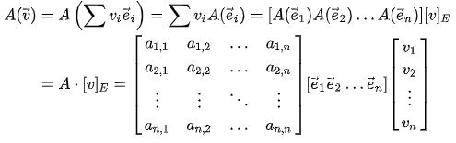

**Figure 19: First Person controller’s hierarchy and wireframe representation**

1. **Character controller:** interface of Unity input set, press W/A/S/D to move forward, left, backward, right.
2. **Capsule collider:** Since this project needs to simulate human walking, the capsule is the most perfect shape to represent the human body. It prevents character controllers from traversing other models and colliding, and acts as a medium to trigger interactions. (Ma & Zhao, 2010)
3. **First Person Controller (C# Script):** Simulate human behavior (walking, jumping, running, head shaking), free-rotating perspective, moving speed, moving sound, gravity effect.

**Drone controller:**

1. **Component:** Transform, Camera, Audio listener, Character Controller, Capsule collider, Rigidbody, Drone Controller (C# Script), etc.
2. **Character controller:** interface of Unity input set, press W/A/S/D to fly forward, left, backward, right.
3. **Drone Controller (C# Script):** almost same as first person controller, just canceled the gravity effect.

**VR controller:**

**Set up steps:**

1. Get inside the LRC and have a look
2. Take six pictures at one time
3. Use tools to joint six pictures at one position into one panorama
4. Transform this panorama into a material
5. Assign this material to a sphere
6. Use shader script to make this material inside-visible
7. Set a camera at the center of the sphere
8. Use script to make camera rotate free at any angle

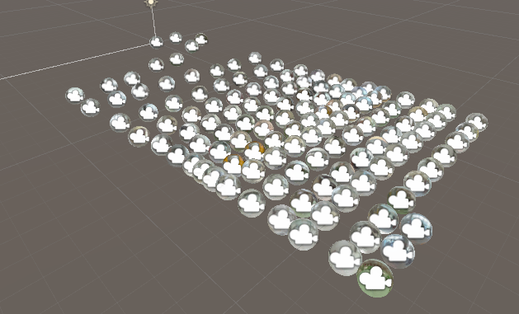

**Figure 22: VR scene**

**Script:** Control the spot users can stay, Press “W” to switch to next camera; Press “S” to switch to previous camera; Press “Q” to back to main scene. Use setActive() to call different cameras. Use LoadScene() to back to main scene.

### 2.5.2 Map system

**Mini map:** In fact, minimaps are tied to character controllers. Initially, set up a camera directly below the character controller in order to obtain a two-dimensional picture of the character on the map in real time. It will render this picture to a raw image and present it in the form of UI. This is the Mini map.

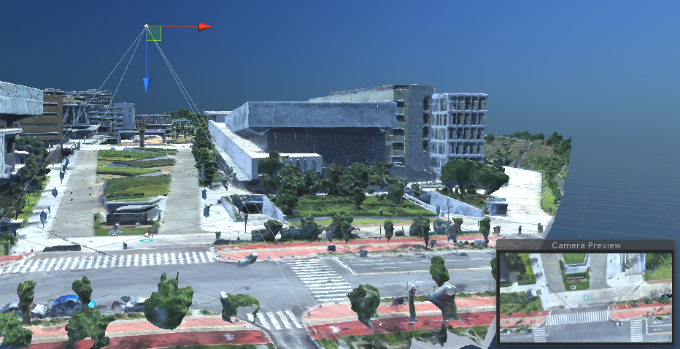

**Figure 23: Mini map camera and its preview**

**Navigation system:**

1. **Pre-processing of the scene:** A plane with a top view of the campus; Multiple colliders are selected in areas that cannot be walked, and they are listed as wall layers; Two spheres set as the starting point and the target point.

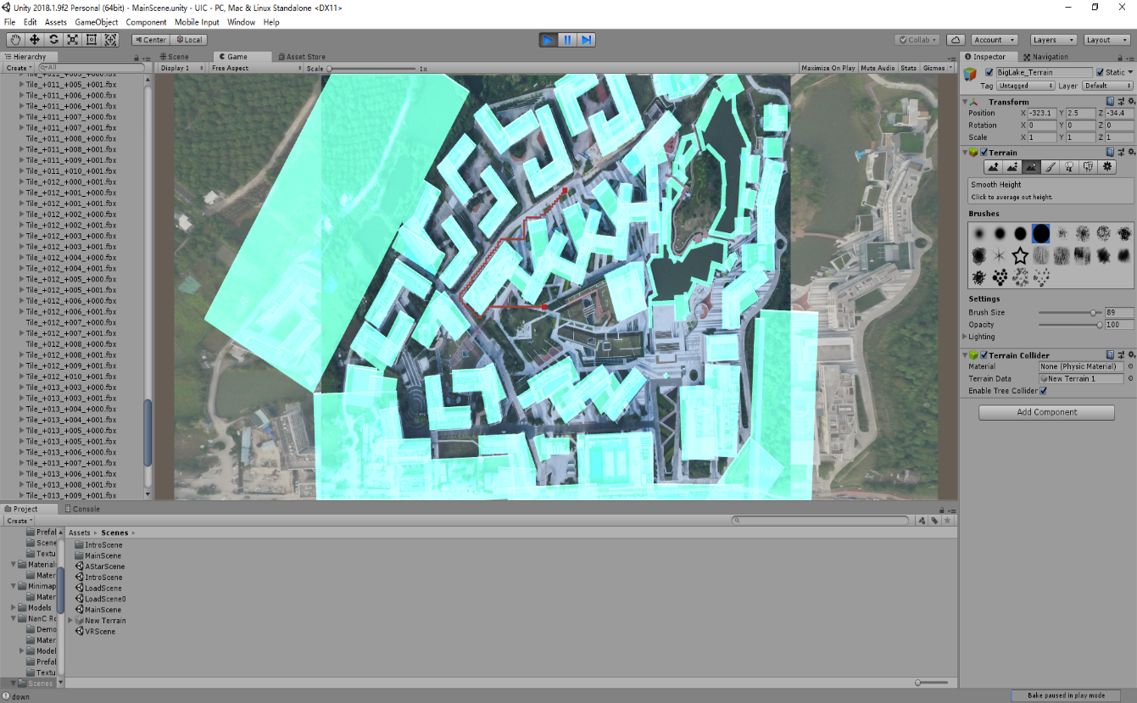

**Figure 24: Navigation interface**

1. **A-star algorithm:** The A*(A-Star) algorithm is the most effective direct search method for solving the shortest path in a static road network, and is also an effective algorithm for solving many search problems. The closer the distance estimate in the algorithm is to the actual value, the faster the final search speed. The principle of the A* algorithm is to design a cost estimation function: where the evaluation function F(n) is an estimate of the least cost path from the starting node to the target node through node n, the function G(n) is from the starting node to The actual cost of the n-node having passed the path, the function H(n) is the estimated cost of the possible optimal path from the n-node to the target node. The function H(n) indicates the heuristic information used by the algorithm. It is derived from people's understanding of path planning problems and relies on some empirical estimation. According to F(n), the cost of the current node can be calculated, and the node that can be reached next time can be evaluated. Use the process of finding the point with the lowest value for each search and then proceeding to search out, and find the optimal path step by step.

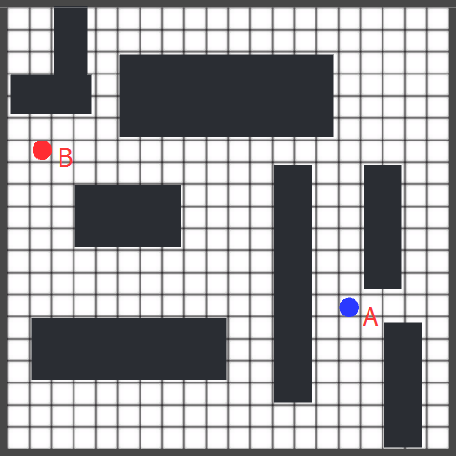

**Figure 25: A- star algorithm sample graph**

* The Search Area: divide the area to be searched into square grids. This special method simplifies the search area to a 2-dimensional array. Black grids are not walkable. Others are walkable.
* Starting the Search: Create Two sets: Open set: open set records all generated nodes (grids) that have not been investigated (nodes are concerned as final path); Closed set: closed set records the visited nodes (they are not concerned in final path). Starting from point A, the target point is point B. First, the nodes of node A will be put into the open set. Then, traverse all neighbor nodes (4 horizontal and vertical nodes, 4 diagonal nodes) of the start point and put them into open set, set start point A as their parent node. Put node of point A into the closed set, which means it have already been visited and not in concerned.
* Path Sorting: choose next node by this cost function: F = G + H; G is the moving cost of moving from start point A to the specified grid n; H is the estimated cost of moving from the specified grid n to the target point B. The path is generated by iterating through the open set and selecting the grid with the smallest F value. First, consider about the G cost of point A. Go horizontally or vertically cost 1. Go diagonally cost approximate value 1.4(Pythagorean theorem)

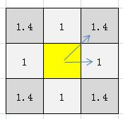

**Figure 26: Cost of going different ways**

Then, estimate the H cost of every neighbor node, there are 3 ways (Ignore the walls which cannot walk).

Manhattan distance (Only go horizontally or vertically):

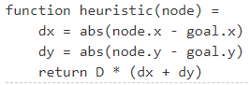

**Figure 27: equation of** Manhattan distance

Euclidean distance (Use diagonal movement as much as you can):

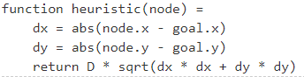

**Figure 28: equation of** Euclidean distance

Diagonal distance (Use diagonal movement instead some of horizontal movements or vertical movement (depends on which distance is farther: distance along x axis or distance along y axis)):

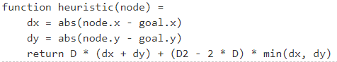

**Figure 29: equation of Diagonal distance**

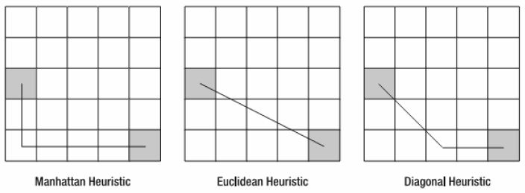

**Figure 30: sample graph of three distances**

In this case, diagonal heuristic is chosen, since it more flexible to find a path. Compute F cost of each neighbor nodes. Then, pick the smallest F cost node, and put it into closed set. The node which just picked out become current node, and then loop the execution of previous steps. Compute each neighbor nodes’ G cost and F cost. If its neighbor nodes are not in the open set, put them into open set and set current node as their parent node. If its neighbor nodes are already in the open set, find out the possibility of find a better path depends on G cost value. If its neighbor node is in the closed set, just ignore them (Rhino, 2003).

* Continuing the Search: Add the end point to the open list, the path has been found. The search endpoint failed, and open list is empty, there is no path at this time. Starting from the end point, each square move along the parent node to the starting point, this is your path.
* Implement in unity: create a class called Node, then create a script called Grid.cs to create grid for all the scene. It can also figure out which part are not walkable part in the scene. Create pathFinding.cs, which mainly writes functions that calculate the shortest distance. By calculating the cost function of the current node to the target node, the most suitable neighbor node is selected, stored in the open set, and finally the stored node is inverted in Grid.cs as the final shortest path, through Unity. Line renderer renders a red route in the scene.

### 2.5.3 Weather system

The weather system simulates realistic visual effects for the scene with eight different sky effects. They include: sunny, light rain, cloudy, stormy, snowy, sunset, night and aurora. The process of implementing each sky effect is different. We have written a skyModule.core which integrates various parameter settings, including the color gradient of the skybox, the influence of hours, months and latitude on the position of the sun and the moon. The change in the color of the sun to the color of the cloud, the relationship between the size of the snow, the rain and the wind, and so on. Next, the detail of how to achieve each weather and their performance in the scene will displayed as below.

1. Sunny day: skyModule.hour equals to 12, skyModule.latitude equals to 0, skyModule.cloudArea equals to 0.
2. Light rainy day: skyModule.hour equals to 15, skyModule.latitude equals to 30, skyModule.cloudArea equals to 0.5 (maximum value is 1), skyModule.rainAmount equals to 0.3 (maximum value is 1).
3. Cloudy day: skyModule.hour equals to 15, skyModule.latitude equals to 30, skyModule.cloudArea equals to 0.8 (maximum value is 1).
4. Stormy day: skyModule.hour equals to 15, skyModule.latitude equals to 30, skyModule.cloudArea equals to 1, skyModule.rainAmount equals to 1, skyModule.lighting equals to 1 skyModule.windAmount equals to 1.
5. Snowy day: skyModule.hour equals to 8, skyModule.latitude equals to 30, skyModule.cloudArea equals to 0.3, skyModule.snowAmount equals to 1, skyModule.windAmount equals to 0.5.
6. Night: skyModule.hour equals to 23, skyModule.latitude equals to 0, skyModule.cloudArea equals to 0.
7. Sunset: skyModule.hour equals to 18, skyModule.cloudArea equals to 0.4.
8. Aurora: skyModule.latitude equals to 90.

Particle system: Particle systems represent techniques for simulating some specific blurring phenomena in three-dimensional computer graphics that are difficult to implement with other traditional rendering techniques. Frequently used particles to simulate phenomena such as fire, explosion, smoke, water, sparks, fallen leaves, clouds, fog, snow, dust, meteor trails or abstract visual effects such as illuminating trajectories. In this project, particle systems is the main component used to simulate granular effects such as raindrops and snowflakes, and then change some values in the particle system components by parameters in skyModule.core.

Shader: In the field of computer graphics, a shader is a computer program originally used to perform image shading (calculating illumination, brightness, color, etc. in an image), but has recently been used to do a lot of work. In different areas, such as dealing with CG effects, shadow-independent movie post-processing, and even other areas not related to computer graphics. There is a high degree of freedom in using shaders to calculate rendering effects on graphics hardware. Although not a hard requirement, most shaders are currently developed for GPUs. The GPU's programmable graphics pipeline has completely replaced the traditional fixed pipeline and can be programmed using the shader language. The pixels, vertices, and textures that make up the final image, their position, hue, saturation, brightness, and contrast can all be dynamically adjusted using the algorithm defined in the shader. External programs that call shaders can also modify the parameters in these shaders using external variables and textures provided by the shader. We use shaders to implement some of the more complex effects, such as the gradient of the sky, lightning, the color of the sunset, the humidity of the ground when it rains.

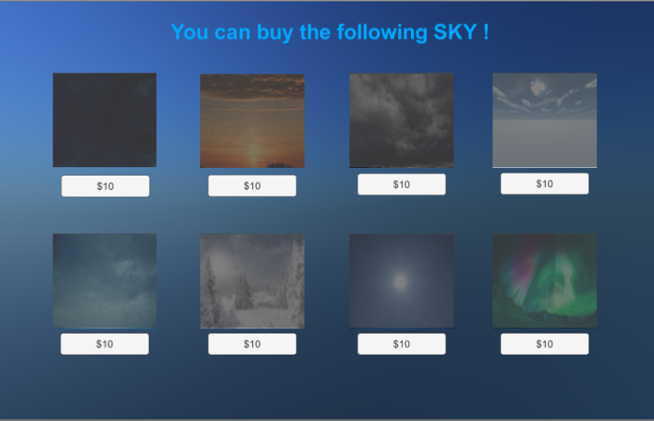

**Figure 31: Interface of weather system**

### 2.5.4 Interaction

Interaction means that some objects in the scene can be automatically generated corresponding to the user's manipulation of the character controller. These interactions can be popping-up interfaces, playing animations, playing sound effects, and even the appearance or disappearance of objects. Some interactive triggering systems can be added into the game project. The details are as follows:

Character get tips: when the game begins, character can look at the tip board, and the board will pop-up with an interface which can tell you how to play with this game.

Characters get companion robot: after user read the tips, it will pop-up another interface at a robot stone carving. It shows “Press [F] to get a companion robot”. After pressing ‘F’, user will get a robot.

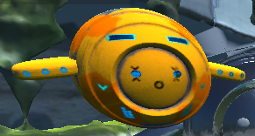

**Figure 32: Companion robot**

Character get coins: there are a lot of rotating coins on the ground, the character controller touches them, they will disappear immediately, and a beep will sound at the same time. At the same time, the character's backpack will also increase the corresponding gold coin value. The sum of these gold coins is just right. Can be used to purchase all weather effects. In particular, touching the gold coin triggers the egg UI, which is different from touching a regular coin.

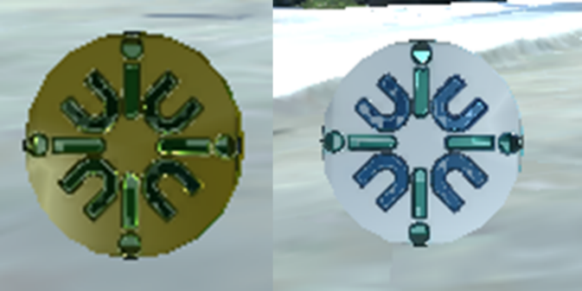

**Figure 33: Left: gold coin; right: normal coin**

Characters enter the library: a diamond-shaped landmark is hung in the doorway of the campus library. When it is close to it, the cursor and prompts will be displayed. Press F to enter the VR scene.

Character Trigger Eggs: If the character comes to the lake island on the campus through the small bridge, the fog will appear on the island and the peach petals will fall.

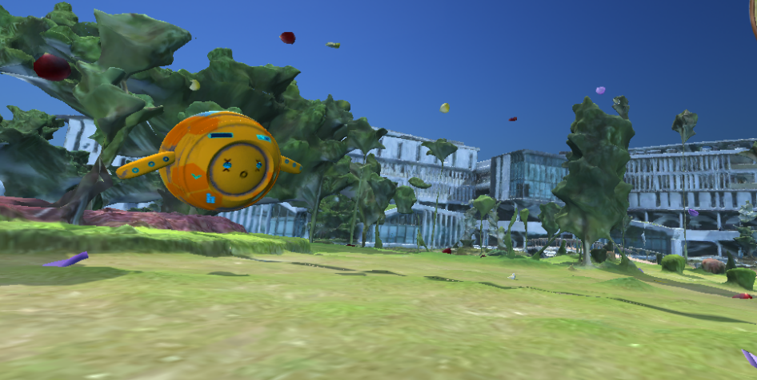

**Figure 34: Peach petals fall**

Ray cast: In the game, users often use the mouse to control the movement of the object or the mouse to pick up an object. There are also shooting games, bullets hit the target, and so on. These all require Physics.Raycast and ray. It is obvious that they are important. A ray is an endless line that is emitted in one direction by a point in the 3D world. In the trajectory of the launch, it will stop once it collides with other objects. In the API documentation, Ray is a structure that produces rays in world space, starting with the camera's near clipping plane and passing through the screen position (x, y) pixel coordinates (axis z is ignored). The coordinates in the screen emit a ray that stops at the collider and generates a trigger event by judging the distance. (Unity - Scripting API, 2019)

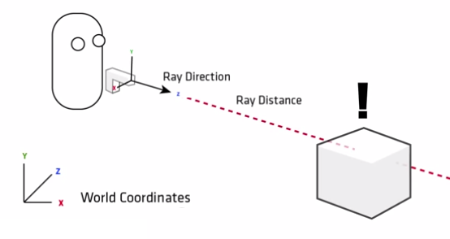

**Figure 35: Ray cast sample graph**

setActive(): activeSelf (read only read-only): The active state of the object itself, corresponding to whether its checkbox in the inspector is checked. activeInHierarchy(read only read-only): Whether the object is active in the hierarchy. In other words, to make this value true, the activeself state of this object and all its parent objects (and ancestors) are true. An object is visible in the scene (not hidden), so not only its own activeSelf is true, but all its parent (and ancestor) activeself states are true. The activeInHierarchy state represents the actual active state of the object in the scene. It represents the activeSelf state of the object and all its ancestors. The activeSelf corresponds to whether the checkbox in the inspector is checked. The activeSelf state represents the activeSelf state of the object itself, so when the object itself activeSelf is true and the activeSelf state of all its ancestors is not all true, the activeInHierarchy state of the object is false. As for SetActive, the change is the activeSelf state of the object itself, so when an object is setActive, it may not be activated in the scene because its ancestors may be inactive. SetActiveRecursively, changing the activeSelf state of the object itself and all its children, is equivalent to calling SetActive on the object itself and all its children.

OnTriggerEnter(): OnTriggerEnter() is used to determine the contact between two rigid bodies. When one of the rigid bodies with the OnTriggerEnter() function script is loaded into the collider of another rigid body, the trigger will change the statement from false to true. The operations inside the function can take effect.

### 2.5.5 UI and animation

The interface style of this project is simple, clear and user friendly. At the beginning of the project there are also some operations that mix animations. In the background of an animation loop, the UI bar has only four buttons. In the setting button, it call Math.Lerp() to make the value of the scroll bar equal to the animation playback speed and the animation volume; In the middle, with the timer and Transform.translate(), it can achieve a rolling subtitle effect similar to the end of the movie. In the UI of the main scene, there is a UI that always exists such as a Mini map, and there is also an interface like a weather effect purchase interface that needs to press a certain key to pop up. These UIs carry the main functions of the game, with a clear division of functions and simple operation.

### 2.5.6 Optimization

Coroutine and Asynchronous loading: The execution of a coroutine can be suspended anywhere with a yield statement, and the value of the yield return determines when the coroutine resumes execution. Coroutines are extremely useful in coordinating operations performed in a few frames. Coroutines have almost no performance overhead. StartCoroutine will usually return immediately, but you can also get the value of the returned result. However, this step will not take effect until the end of the coroutine. StartCoroutine is to start a coroutine, yield return is the place where the iterator block returns the call iteration. The coroutine is not multi-threaded, it is inside the main thread. The real purpose of coroutine is to do a relatively time-consuming thing, such as loading resources in the game. For example, there are 30 resources loaded, but it takes a lot of time to load it. It is impossible for the player to wait for so long in the start. Currently, the role of the coroutine appears. The coroutine is before each frame lastUpdate. Executing the code before the yield return, after the update, the code after the yield return is equivalent to looping once per frame (provided that your coroutine has a loop body, otherwise one frame is executed), so it will not be stuck in this load 30 Here are the resources, but you continue to do your things in the update. Loading one asset at a time, the consuming time is obviously less than loading thirty assets at a time. Using coroutines, game can be switched from one scene to another faster with asynchronous loading. Here is a progress bar to indicate that the loading progress indicates the total number of resources loaded in the background each time the frame is updated.

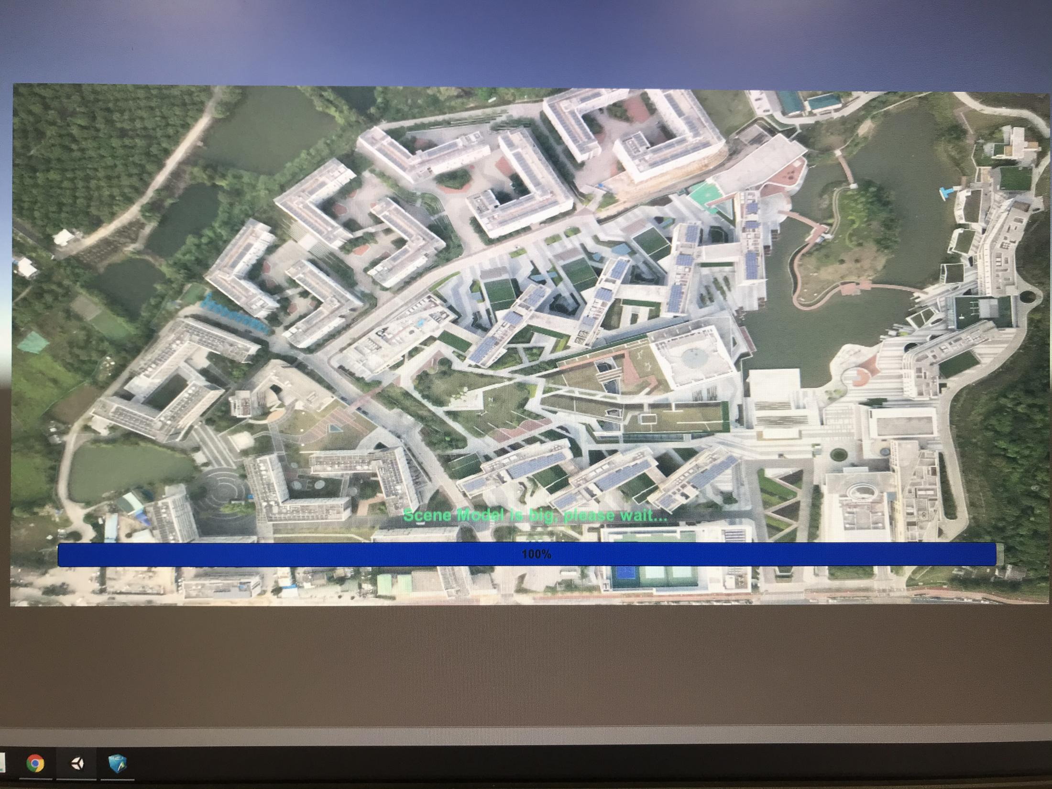

**Figure 36: Progress bar**

Occlusion culling: When the scene contains a large number of models, resulting in reduced rendering efficiency (i.e., the frame rate FPS is reduced), the use of occlusion culling technology, can make those blocked objects not rendered to improve rendering efficiency. The principle is to create an occlusion area in the scene space, which is composed of cells; each cell is part of the entire scene occlusion area, these cells will split the whole scene into multiple parts, when the camera can see the cell, the object representing the cell will be rendered, and the others will not be rendered. Rendering a game object within the field of view. Rendering outside the field of view. In practice, click on Occlusion Culling in Window in Unity, select Occluder Static, and then click Bake to generate the grid to block the culling calculation. It does not display outside the field of view in the field of view. Finally, adding new objects needs to be re-baked.

Use light mapping: Generating light maps in advance effectively avoids the computational effort of implementing lighting in the process. In Unity, you can perform scene baking and create a new lighting settings file. When loading, it will effectively increase the speed of opening the scene.

Limit Draw Calls: use SetActive(false) to disable some game objects.

# 4 EXPERIMENTAL RESULTS

## 2.2 System pipeline

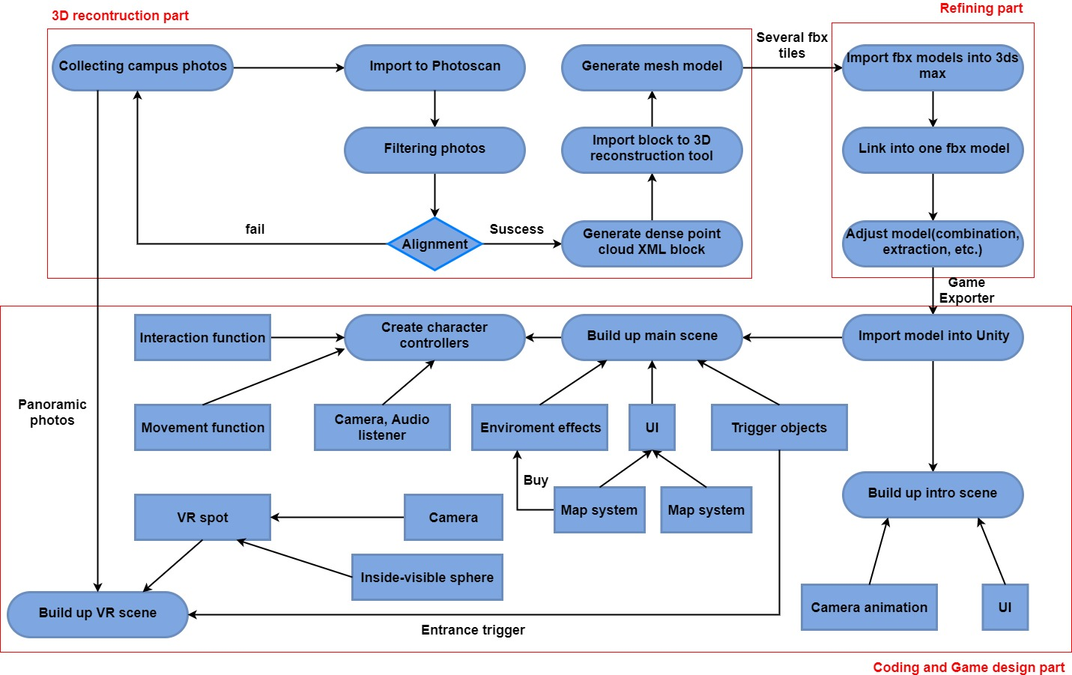

**Figure 10: Pipeline Chart**

The general workflow of this project can be divided into three parts. The first part is 3D reconstruction. At this part, it shows how to transfer plenty of images into a model. The second part is refining. It will introduce the way of using 3ds max’s Edit Mesh adjust model. It will also show another of lower the size of model and higher the accuracy of model. The last part is game designment and development. It shows the general framework of game function implementation. The work of these three parts is carried out simultaneously. Since 3D reconstruction is the most time-consuming part, the common way is implementing some of the game's functions and scripts, while at the same time improving the accuracy of the previously reconstructed model and updating the model from generation to generation. In general, it takes about 15 days to rebuild a complete campus model, but it takes only about 3 hours to rebuild a small, sophisticated building (campus sculpture, alumni wall, stone monument, etc.).

### 2.3.2 Workflow

1. **Collecting campus photos:** Use the drone to shoot the entire campus in five lanes (one vertical downward lane, four inclined lanes). When tilting photography, the head of the drone is kept inclined at a downward angle of 45 degrees. The four headings are from west to east, from east to west, from south to north, and from north to south. Shooting a small building separately requires wrap-around shooting (using a normal camera to wrap multiple circles from bottom to top, depending on the shooting). Keep the distance between the camera and the center of the object constant during shooting. The slight deviation is negligible. When shooting a VR scene, panoramic camera is the best choose to enter the indoor shooting and set up the position. Route needs to be stipulated at first. Shooting at the appropriate point on the route (opened position), and it will produce six fisheye photos at a time. Each time the panorama position representing one position is successfully established, avoiding someone in the lens when shooting. Pre-appearing, this may result in a misplacement in every six stitched panoramas.

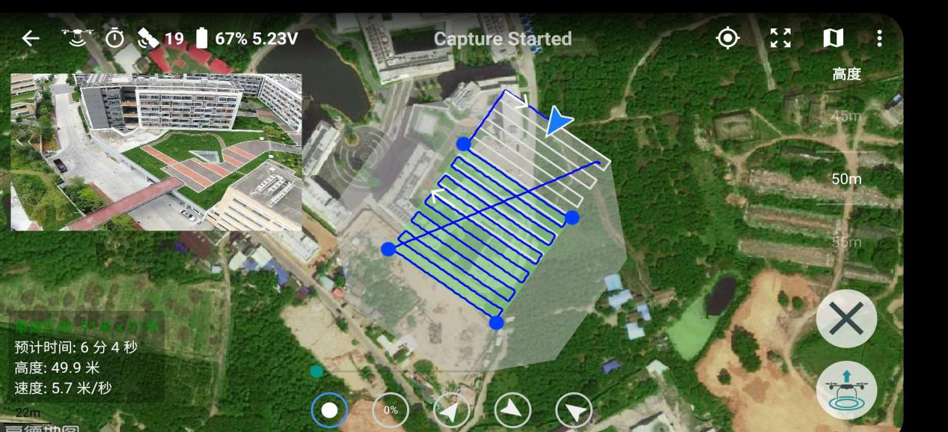

**Figure 11: Method of shooting big area**

### 2.1.2 Related devices

* **Cameras:**
  + - 1. DJI Mavic 2 Pro: Tilt photography, most photos of the school, and points of interest surround shooting of small buildings.

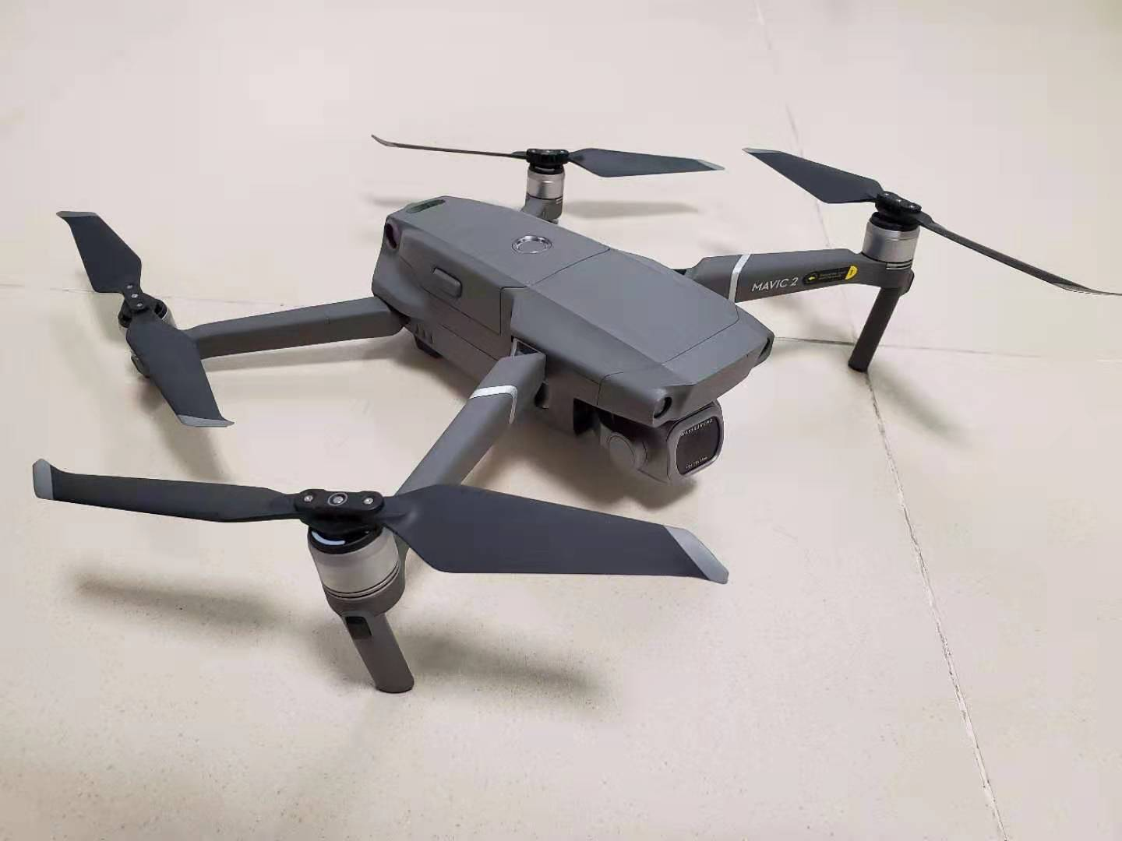

**Figure 4: DJI Mavic 2 Pro**

Smart photo (iPhone 7 plus & Samsung galaxy s9): mostly use for shooting around with small buildings or places like eaves where drone cannot reach to.

1. **Import modeling photos into Photoscan:** Photoscan is an intermediate tool that calculates more accurate Aerial triangulation with less chance of failure. ContextCapture itself also has the function of calculating Aerial triangulation, but after many experiments, it founds that wrap-around shooting is not suitable for ContextCapture to export Aerial triangulation, there will be 100% error, and ContextCapture has high requirements for the consistency of aerial height, and it has low fault tolerance. Next, Photoscan can be regarded as an intermediate tool to export the Exchange block in XML format, and then import it into ContextCapture in the next step. Photoscan first extracts camera position information (GPS information) for each photo, then converts the photo to point cloud to the corresponding world coordinate system by calculating the relationship between depth and camera position. If the generated point cloud can already see the outline of the building with the naked eye, there is not many points scattered or sunken, indicating that the calculation result is nearly successful. The more photos you use, the denser the point cloud will produce, and the better the 3D reconstruction will be. However, the selection of the camera position is not good, these extra photos are not available, and the result may not be good with a small number of accurate photos. If the first calculation of dense point clouds are not effective, you can choose to recalculate, and the next result may be accurate. The Aerial triangulation block produced by Photoscan stores the initial information of the model and the index of the photo file, and finally exports it in XML format. Of course, Photoscan can also produce a mesh model, but the effect is not as good as ContextCapture, so the best of each software can be taken to achieve the best results.

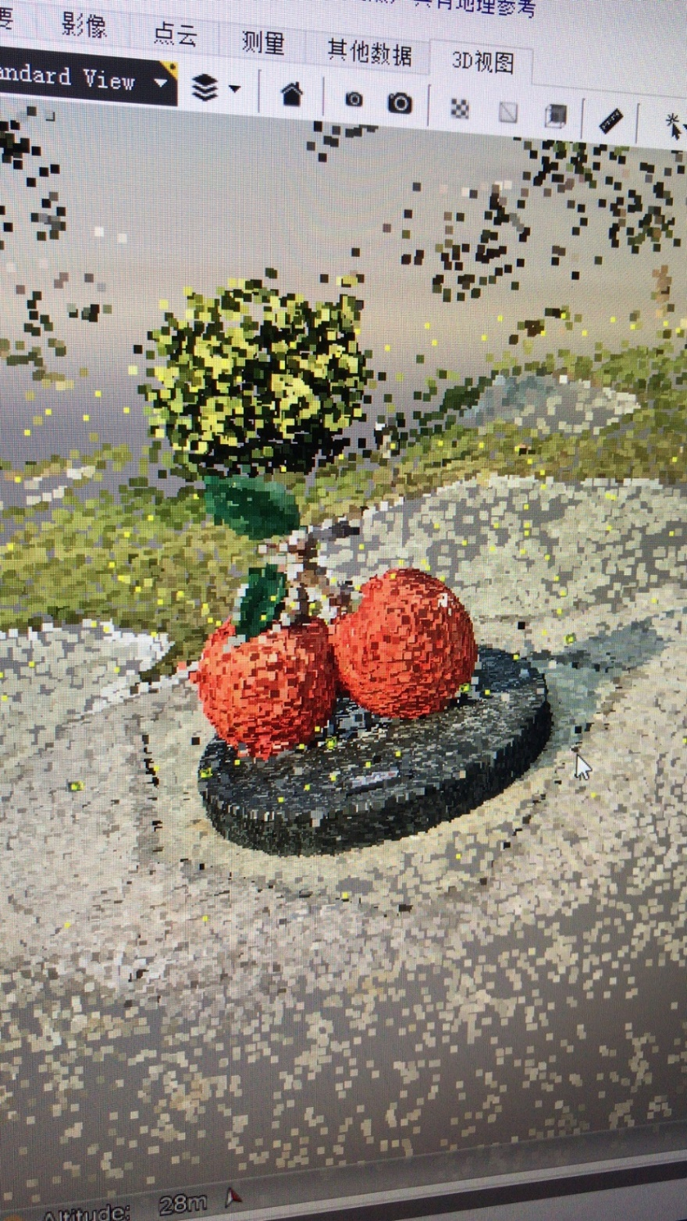

**Figure 13: Dense point cloud of small sculpture**

1. **Generate mesh model in ContextCapture:** In ContextCapture, reconstruction products can be produced directly. ContextCapture provides internal tools to select the reconstruction range, crop the model and select the quality of the texture to display the texture with different accuracy. The result of the modeling will inevitably lead to the appearance of holes. Select the Fill tool to fill the holes and assimilate a portion of the fill with the surrounding texture. ContextCapture also recommends tile modeling based on the size of the computer's memory, because the computer hardware limitations (only 64G memory), which makes us need to divide an entire campus model into more than two hundred tiles for production, and finally export to fbx format. After the model, cracks between each tile can be found faintly.

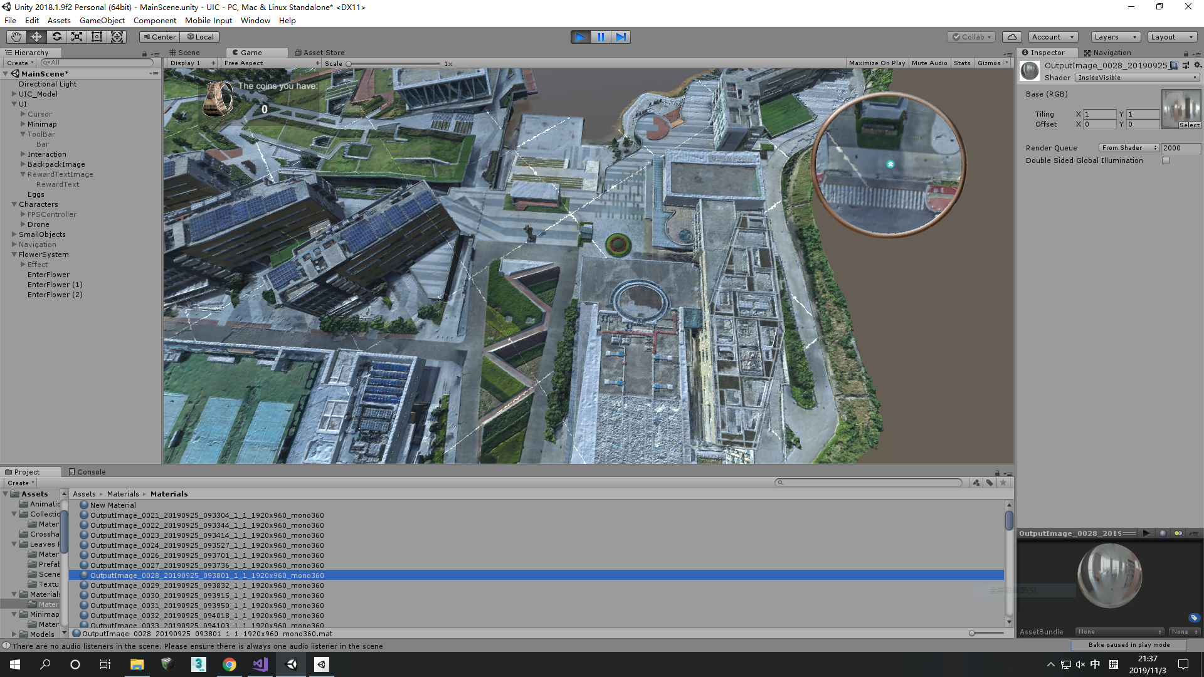

**Figure 14: Cracks between each tile**

## 2.4Model Refining

### 2.1.1 Related software (based on Windows 10, x64)

* **Smart3DCapture** was developed in 2011 by two PhDs: Jean-Philippe Pons and Renaud Keriven in the Sophia Antipolis Science Park in France. It is a groundbreaking photogrammetric product that processes photographic data from any source from smartphone to lidar into a representation that matches the background in the building model and construction modeling environment. After Acute3D was acquired by Bentley Systems, Smart3DCapture enabled photography and 3D scanning to be used in conjunction with CAD modeling technology to present realistic 3D innovations in facility projects. This software provides features for importing image groups taken by drones and stitch them into 3D models by cutting into different tiles.

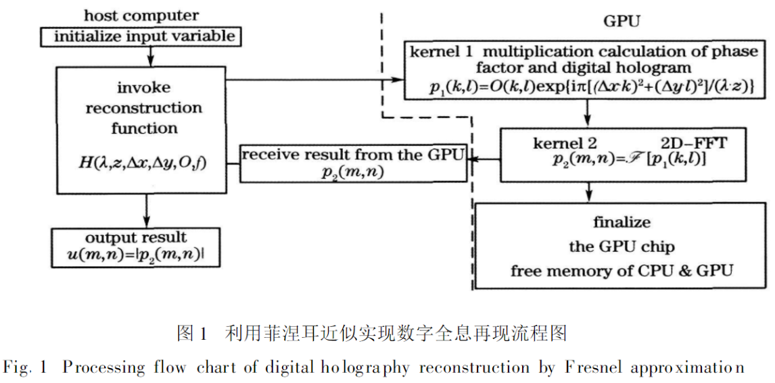

**Figure 2: Principle of ContextCapture**

* **3D Studio Max**, often referred to as 3d Max or 3ds MAX, is a 3D animation rendering and production software developed by Discreet (later merged by Autodesk) based on PC system. Its predecessor is the 3D Studio series software based on DOS operating system. 3D Studio Max is a very good 3D modeling and special effects production software. The model built by UAV can be import to perform many human operations, including post-repair, animation of single or multiple objects, adjustment of materials and textures, etc. Wait. After the adjusted model is imported into Unity3D, it will reduce the workload and present a better visual effect.

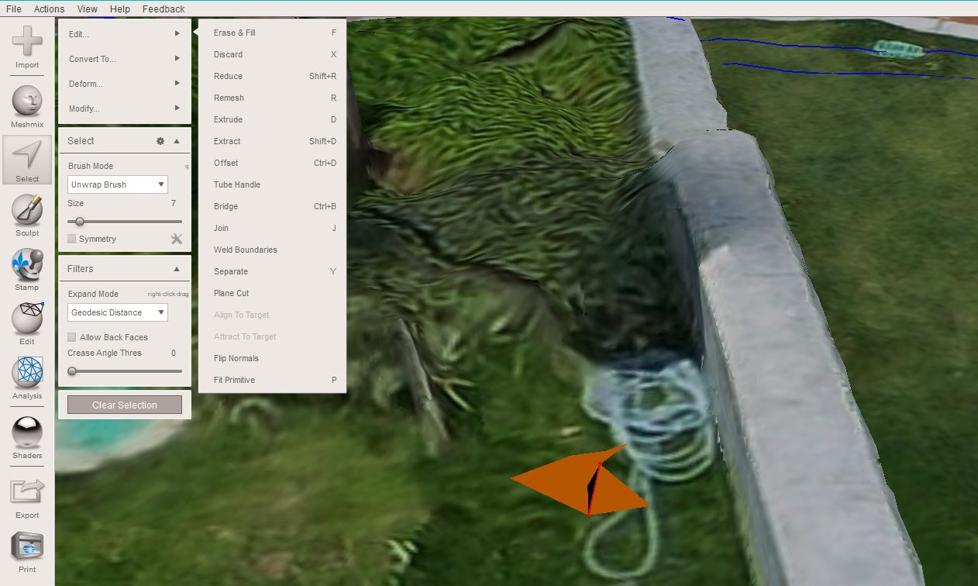

**Figure 3: Select the part of model use brush, then do the several operations above**

* **Unity3D** is a cross-platform game engine developed by Danish Unity to enable visualization of scenes and three dynamic models. It integrates editors, cross-platform publishing, shaders, scripts, etc., with hierarchical development. Environment, visual editing, dynamic game preview features. In today's mobile devices and different operating systems, developers only need to transplant Unity projects to different operating platforms through corresponding methods, which greatly reduces the workload and is extremely versatile. In the Unity3D engineering project, the objects in the project are controlled by a script program, usually scripted in C# language, which provides some event response functions to process the event response of the objects. These event functions are executed in a predetermined order. In this project, the user (player) will follow the camera's perspective in a first-person perspective. Through the character controller (handle) of this game, any corner can be reached in the UIC scene. whenever the player reaches each specific situation, interactions (all implemented by C# scripts) will occur (Jin, 2015).
  + - 1. KANDAO Obsidian S&R: Taking indoor photos (focus on the library) for VR scenes, six fisheye lenses are shot at the same time, and finally stitched into a panoramic photo.

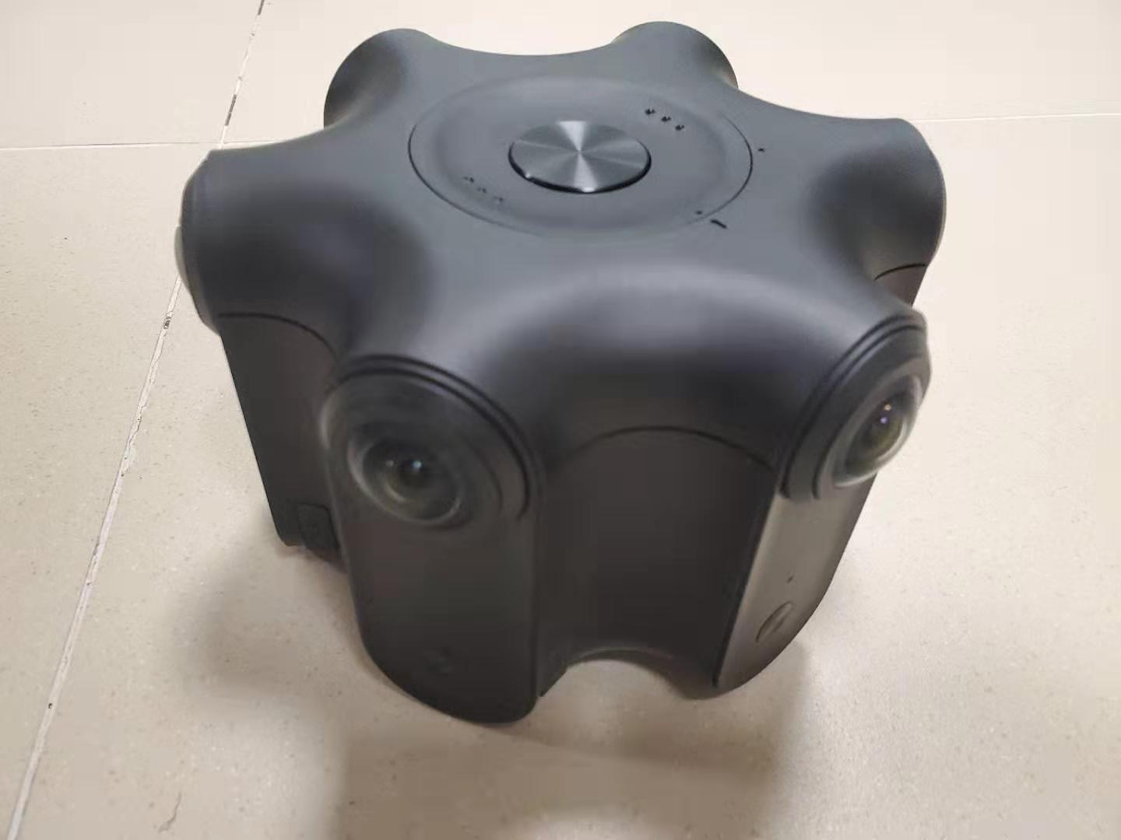

**Figure 5: KANDAO Obsidian S&R**

* **Hardware:**
  + - 1. GPU (NIVDIA Titan RTX): In fact, the GTX 1080 Ti graphics card is enough for us, but the superior performance of the Titan RTX can greatly improve the speed of 3D reconstruction speed and operations 3ds max. The DriectX11 provided by the Windows platform also brings more possibilities to the AI chip in the Titan RTX. For the physical effect simulation of unity, it is necessary to have a good graphics card to support. NVIDIA's PhysX physics engine supports the physical collisions, gravitational effects and particle systems required in the game scene well.
      2. CPU (Intel XEON E5): Modeling requires many photos to be processed and floating-point calculations, which means a powerful CPU is needed. Multithreading can handle multitasking synchronously, and multiple cores allow computers to handle higher throughput digital levels. Xeon-E5 series CPU has 16 threads and 8 cores, which brings more efficiency to this project.
    - **3D projector (Panasonic PT-HZ900C):** Because this project should be truly immersive, this 3D projector can be choosing to enhance the stereo. Its principle is: when watching 3D content, the signal from the built-in infrared emitter of PT-HZ900C precisely controls the left and right shutters of active 3D glasses, and quickly displays different images of left and right eyes, thus in the brain. Lag is generated to achieve a three-dimensional effect. The 3D motion image reset technology compensates for the time delay by generating a correct positioning image, resulting in a smoother and smoother 3D dynamic moment.

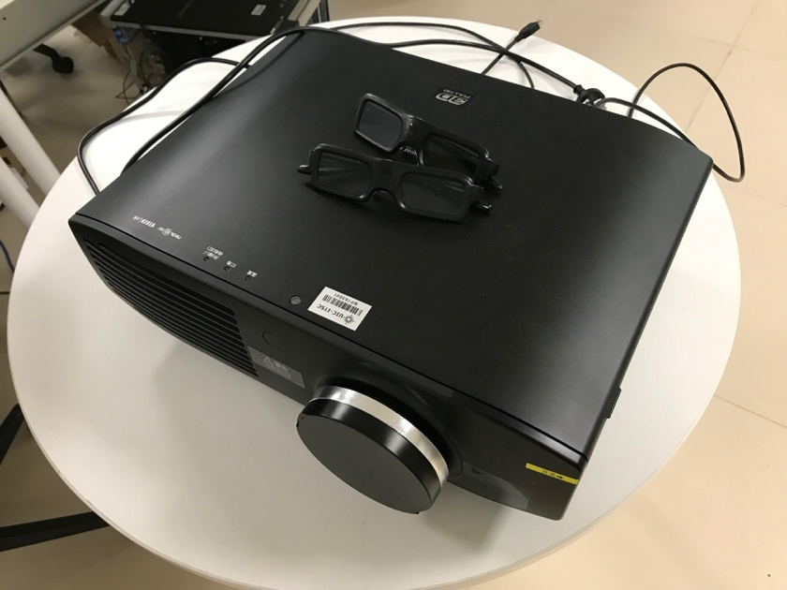

**Figure 6: Panasonic PT-HZ900C**

### 2.4.1 Impact of model’s format

ContextCapture's native model format 3mx, 3sm is based on Bentley's software such as Context Capture viewer. The model of this format cannot see cracks in the viewer, whether it is divided into tile production or monolithic production. Besides, the material is more realistic, and the corners of the model surface are not obvious. In general, fbx is the most compatible model file format. The model of this format does not have the performance of the Bentley native format. The surface will have obvious triangular patches, and the material is like cartoons. The game is not real. Currently, the fbx format is the best choice, so improving the quality of the model itself is the key.

### 2.4.2 External influence of model quality

1. **Photo quality:** 3D reconstruction is best to take pictures with the same model of camera, the photo must first have high pixels, and then the sharpness is higher, so the resolution of the photo will be higher, the depth calculation will be more accurate. There are different camera sensor parameters configured in ContextCapture, and choosing the correct parameters will achieve better results.
2. **Overlap rate:** In general, 3D reconstruction requires an overlap rate of more than 80%, and too low an overlap rate leads to missing details.
3. **Weather effects:** It is best to shoot on a sunny day. The shooting time is best in the morning or afternoon. The direct light at noon will reflect the white buildings, and the objects such as glass and water will be more reflective, which will eventually lead to holes in the model.

### 2.4.3 3ds max’s operations

Editable mesh is the most commonly used modifier in this project. The Edit Mesh modifier provides various tools for editing all the sub-object levels of the target objects (front, side, and face/mix/element). The Edit Mesh modifier matches all the features of the underlying editable mesh object, except that you cannot set the sub-object animation in the Edit Mesh. See "Editable Mesh" for a complete parameter reference. If possible, it is easier and more reliable to implement a significant production model at the editable mesh level without storing these edits in the Edit Mesh modifier. The Edit Mesh modifier must copy the geometry passed to it, and this storage can cause the file size to grow. The Edit Mesh modifier also establishes a topology affiliation that is affected if the previous operation changes the deformed structure sent to it. However, in some cases using the Edit Mesh modifier is the preferred method: you want to edit the parameter object as a mesh, and you want to retain the ability to modify its creation parameters after editing. Before you want to edit the permanent collapse into an editable mesh object, you want to temporarily store the edit in the Edit Mesh until you are satisfied with the results. You need to edit between several objects at the same time, but you don't want to convert them to separate editable mesh objects. There is a modifier in the scale that must still be a parameter, and the mesh must be editable after the modifier is applied. Note: Performing a collapse on an object to which the Edit Mesh modifier is applied produces an object with an editable mesh. Sometimes, mesh models can be change into polygons, but the edition process will be slower, since edit mesh was originally the most basic processing method of max, but it was replaced by a better algorithm after max4. This algorithm is replaced by "edit subdivision edit poly", and then the method of edit mesh is gradually (but mesh is the most stable, many companies require the final output of mesh format, but it does not matter because mesh and poly can be converted at will. Edit poly: In essence, it is still mesh, but the algorithm is better. In order to distinguish, the name is also changed. Beginners of 3ds max’s history are easy to confuse. Poly is the current mainstream operation method, and the technology is leading, there are more convenient modifications than mesh. (Poly burdens the plugin more than meshing).

**Figure 14: Edit Mesh-Selection**

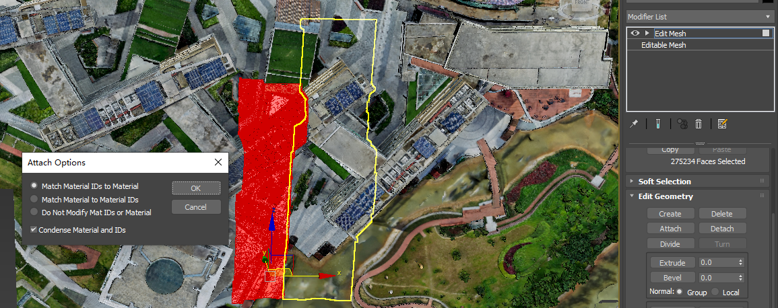

**Figure 16: Edit Mesh-Attach**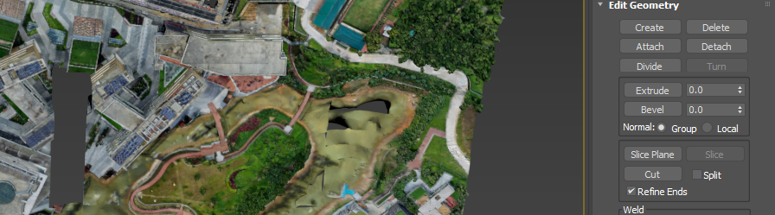

**Figure 17: Edit Mesh-Delete**

* **MonoBehaviour** is the base class from which every Unity script derives. When you use C#, you must explicitly derive from MonoBehaviour. In general, it an API from UnityEngine.CoreModule. MonoBehaviour.Start () is called on the frame when a script is enabled just before any of the Update methods are called the first time. MonoBehaviour.Update () is called every frame, if the MonoBehaviour is enabled. Basically, MonoBehaviour.Update () is the most function has been used, since every interaction behavior need to updated at every frame. There are also many well-defined classes and enumerations can be used when writing C# scripts, and they can also be used with Unity components to achieve different functions.

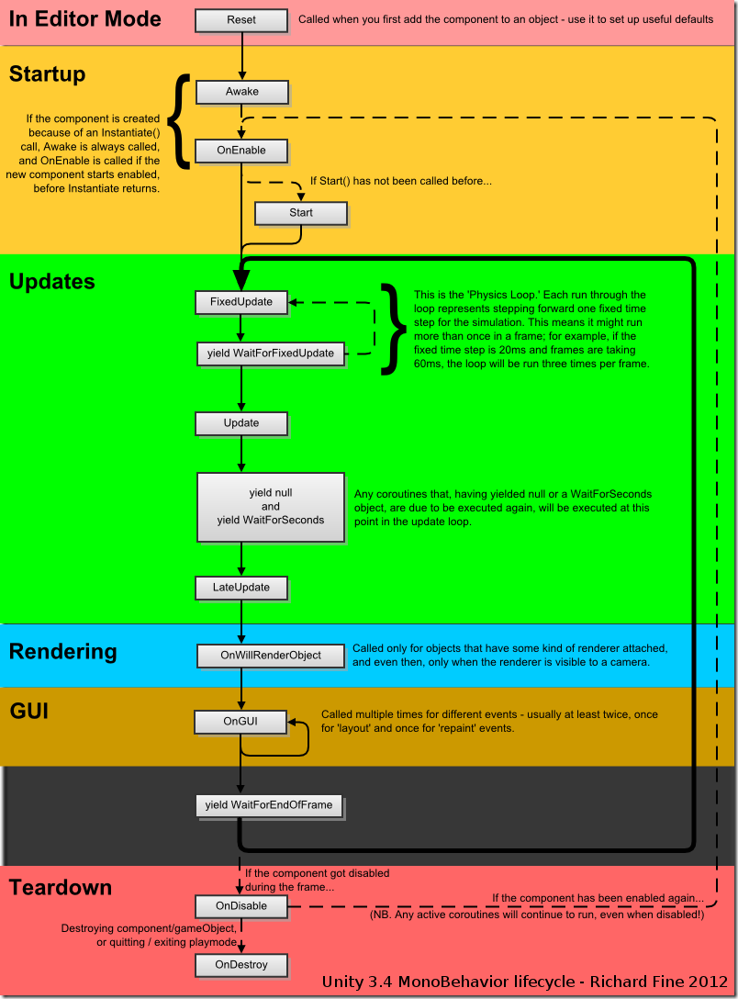

**Figure 8: MonoBehaviour lifecycle**

# 5 DISCUSSIONS AND CONCLUSIONS

In the nearly six-month study, there are many ideas can be concluded, experiences of 3D reconstruction and the idea of ​​the Unity application be summarized. 3D reconstruction is an area that requires a lot of experience to make it work. It is not enough to just understand the relevant theoretical knowledge. 3D reconstruction is also an interdisciplinary field. It is related to surveying, computer graphics, mathematics and photography. Reproduction modeling algorithms are even more difficult. Some existing software can help us meet the basic requirements of the project, but in terms of efficiency, it is still far from expected, and time consumption is the biggest challenge facing the project. Obviously, 3D reconstruction contains many terms, which have profound research value. For this advanced technology, the most important conclusion is that the camera position and weather selection will directly affect the reconstructed results. Of course, a huge number of photos are needed, but many of the unplanned photos taken do not have a positive impact on modeling, which is the conclusion of the previous reconstruction. At the time, 3,000 of the more than 10,000 photos were unusable, which led to poor reconstruction. Later, we tried a more precise flight path and different shooting methods, and the accuracy of the model was greatly improved. The only regret is that high-precision models cannot be imported into Unity (the model itself is up to 4.8G), so the slightly more accurate model is presented in the final game program. When it comes to game programs, Unity has a lot of powerful features to implement. Given the length of the reconstruction, we can only complete the basic project requirements. In my vision, the interactive part can be more abundant, and the coin can be used to redeem more functions, such as allowing the companion robot to be able to navigate the factual voice, the character can enter more interiors of the building, and the animation of the stream is played on the road to make The scene is more realistic. More profoundly, we can thoroughly optimize this project and port the entire project to the mobile phone, so that we can build a server and turn it into an online multiplayer game. If the above ideas can be realized, then it is not only the interaction between people and machines, but also the interaction between people. Users can always switch between real and virtual. All in all, this project is still very malleable. With the advent of the 5G era, we may see similar applications coming from the mobile phone. In the future, this project will be inherited to achieve amazing effects and features.

### 2.3.3 Improvement

In terms of output efficiency, the computer cluster method will greatly improve the modeling efficiency. A single computer in a clustered system is often referred to as a node, usually connected via a local area network, but there are other possible ways to connect. Cluster computers are often used to improve the computational speed and/or reliability of a single computer. In general, a clustered computer is much more expensive than a single computer, such as a workstation or supercomputer. Cluster modeling enables task parallelism. Task parallelism is one of the parallel computing programming models. In this model, each thread executes an assigned task, and these threads are allocated (usually the operating system kernel) to the various compute nodes of the parallel computing system. In a multiprocessor system, task parallelism can be achieved when each processor executes a different thread (or process) on the same or different data. Threads can execute the same or different code. In general, different execution threads communicate with each other at work, but are not required. As part of the workflow, communication is typically done by passing data from one thread to the next. The scheduling of general tasks on the processor is done through the user thread (User Thread, relative to the kernel thread - Kernel Thread). The operating system kernel schedules threads by manipulating the scheduler (Scheduler) to map tasks to individual processors. This scheduling method generally cannot meet the requirements of the user to freely arrange the task: usually the operating system needs to provide a scheduler in the user mode to complete the task. The task of the scheduler is to distribute and balance tasks to a processor as reasonably as possible. After the success of computer cluster, ContextCapture will have multiple computing engines. A model that is generally completed in 15 days can be completed in one day. When the computer cluster is successfully established, ContextCapture will produce a more accurate model. Aerial photography plus ground photography can capture every detail of a building.

# REFERENCES

1. Laporte, S., Skalli, W., De Guise, J., Lavaste, F., & Mitton, D. (2003). A Biplanar Reconstruction Method Based on 2D and 3D Contours: Application to the Distal Femur. Computer Methods In Biomechanics And Biomedical Engineering, 6(1), 1-6.
2. Bailey, T., & Durrant-Whyte, H. (2006). Simultaneous localization and mapping (SLAM): part II. IEEE Robotics & Automation Magazine, 13(3), 108-117.
3. P. Alavesa et al., "Janitor run: Studying the effects of realistic mirror world like game scenes on game experience," 2017 9th International Conference on Virtual Worlds and Games for Serious Applications (VS-Games), Athens, 2017, pp. 179-180.
4. W. Sheng, S. Nakata, S. Tanaka, H. H. Tanaka and A. Tsukamoto, "Modeling High-Quality and Game-Like Virtual Space of a Court Noble House by Using 3D Game Engine," 2013 International Conference on Culture and Computing, Kyoto, 2013, pp. 212-213.
5. Sourin, A. (2004). Nanyang Technological University virtual campus [virtual reality project]. IEEE Computer Graphics And Applications, 24(6), 6-8.
6. Zhang, Y., Yang, X., Xing, X., Wang, Z., & Xiong, Y. (2016). The Standing Calibration Method of MEMS Gyro Bias for Autonomous Pedestrian Navigation System. Journal Of Navigation, 70(3), 607-617.
7. Rhino, M. (2003). A* Pathfinding for Beginners. Retrieved 27 November 2019, from <https://www.gamedev.net/articles/programming/artificial-intelligence/a-pathfinding-for-beginners-r2003/>
8. Asynchronous loading of basic Unity resources and use of Coroutine. (2017). Retrieved 27 November 2019, from <https://blog.csdn.net/fcauto2012/article/details/72801857>
9. Edit Mesh Modifier | 3ds Max 2019 | Autodesk Knowledge Network. (2018). Retrieved 27 November 2019, from <https://knowledge.autodesk.com/support/3ds-max/learn-explore/caas/CloudHelp/cloudhelp/2019/ENU/3DSMax-Modifiers/files/GUID-1CF31D5B-A016-4C8A-93C2-2DB528C0FC4E-htm.html>
10. Technologies, U. (2019). Unity - Scripting API: Physics.Raycast. Retrieved 27 November 2019, from <https://docs.unity3d.com/ScriptReference/Physics.Raycast.html>
11. Castro, K. (2018). Clustered Systems. Retrieved 27 November 2019, from <https://www.tutorialspoint.com/Clustered-Systems>
12. Coroutines in Unity3D C#. (2019). Retrieved 27 November 2019, from <http://www.unitygeek.com/coroutines-in-unity3d/>
13. Ma Linshan, & Zhao Qingfeng. (2010). Design and implementation of virtual library roaming navigation system. Library Science Research (7), 54-57
14. Jin Yonglai. (2015). Design and implementation of interactive indoor 3D maps. (Doctoral dissertation, Jilin University).
15. Chen Yong, Wang Dong, and Chen Ge. (2007). A fast path planning algorithm for automatic roaming of 3D virtual scenes. Journal of System Simulation, 19(11), 2507-2510.

# APPENDICES

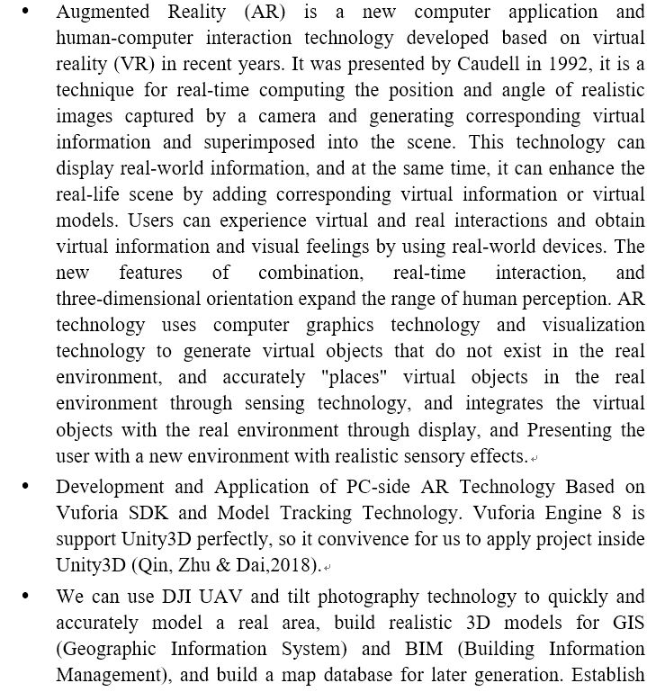

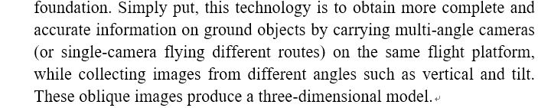

**Collision detection:**

The Unity3D 3D rendering engine includes a collision detection algorithm based on a bounding box. The bounding box performs collision detection by representing the collision volume of the object by a geometry slightly larger than the target model and having a simple geometric structure. Unity3D mainly includes four bounding boxes such as a ball bounding box, an AABB bounding box, a k-Dop bounding box, and an OOB bounding box.

* + - The ball bounding box in the four bounding boxes is the most basic form of bounding box, and the engine represents its collision volume by a sphere slightly larger than the model. If two spheres are in contact, it is determined that two objects collide. This method is simple to implement, but the accuracy is relatively low, and it is suitable for a spherical or nearly spherical model. If the actual model has a large difference from the bounding box sphere, the detection effect is very large. It is relatively simple to determine whether the two spheres collide. By calculating the distance between the two spheres, it can be determined whether the spherical surface is in contact. If the distance between the two spheres is d<rl+r2 (rl, r2 represent the two spheres being measured) Radius) judges that the object collides, and if the distance condition is not satisfied, it is judged that the object does not collide.

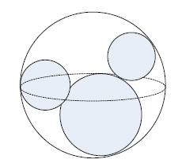

**Figure 3, the ball bounding box collision detection**

* + - The AABB (full name Aligned Axis Bounding Box) bounding box uses cubes to represent the collision boundaries of objects. For square models that are ubiquitous in the scene, this bounding box enables more accurate collision detection. The AABB bounding box finds six planes perpendicular to each coordinate axis in the direction perpendicular to the three coordinate axes according to the shape of the three-dimensional model. In this way, a minimum hexahedron containing the three-dimensional model can be found. Collision detection is determined by detecting whether there are overlapping areas in the direction of the three coordinate axes. The advantage of the AABB bounding box is that the calculation amount is small and the collision detection is easy to implement. The disadvantage is also that when the difference between the specific shape of the model is large, there was a misjudgment.

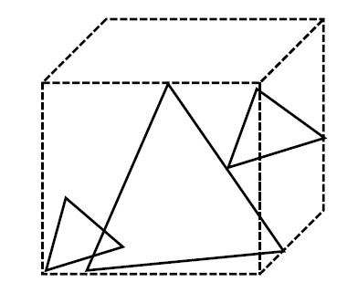

**Figure 4, the AABB bounding box Collision detection**

* + - The k-Dop (full name k-Discrete Orientation Polytope) bounding box is an extension of the AABB box that encloses a three-dimensional model as a collision volume by k/2 pairs of mutually parallel planes. k-Do can be more conformable to the AABB box. Its collision detection algorithm is like the AABB bounding box and needs to be detected in the k/2 direction.
    - The OOB (Oriented Bounding Box) bounding box is like the AABB bounding box. The collision volume of the model is also described using a parallelepiped, and the collision volume is represented by the smallest cuboid surrounding the three-dimensional model. The three axes of the OOB bounding box are selected according to the shape and orientation of the object, rather than being fixed parallel to the three primary axes. In the collision detection process, the collision volume of the detected object will be mapped to the local coordinate system of the reference collision body. On this basis, the distance calculation is performed from the directions of the three coordinate axes to determine whether the object collides.

In the Unity3D, the collision detection system is used for collision detection of the scene. The collision device is based on the above four bounding boxes, including the mesh collider and the prototype collider. The prototype collider is applied to a three-dimensional model with a simple geometric shape. The commonly used colliders include a spherical collider and a box collider. The mesh collider is a model mesh-based collider, and its collision detection is very detailed but computationally intensive. The prototype collider is the more commonly used collider in Unity3D, and its computational complexity is low. It is suitable for simple models or collision detection with low precision requirements. The mesh collider requires a lot of calculations, but its calculation results are close to the real collision effect. The more complex the model geometry results and the more meshes, the larger the calculation of the mesh collider, but the calculation result is also more accurate (Chen, Wang & Chen, 2007).

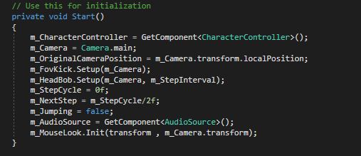

**Figure 20: Declare the Unity components and parameters that need to be called**

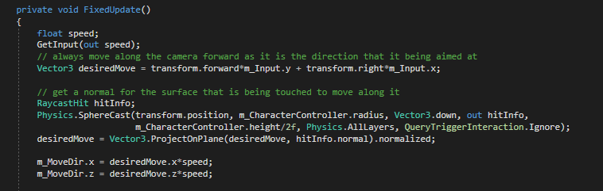

**Figure 21: Fix update the speed**